Laboratory 3: Spirogravitator

Jonathan Pilling

Section 02

***Abstract-* We were able to build a secret weapon with our spirogravitator, based on an RLC circuit and an op-amp. Using Laplace transform techniques, we were able to design the circuit so it produced decaying sinusoids 90º out of phase. We were able to model these sinusoids in Matlab and visualize them.**

1. **Introduction**

Building the spirogravitator circuit, this creates two signals that are 90º out of phase. This circuit could be helpful in powering down a two-phase motor, or maybe in the implementation of an Etch-a-Sketch. The circuit diagram of the spirogravitator is shown in Fig. 1. Input V1(t) is a square wave that excites a damped oscillation in the series components to the left of the op-amp. The design problem was to select circuit components so that voltages V0 and V1 will have equal amplitudes, and will be under-damped with the same frequency of oscillation and the same damping rate, but 90º out of phase. V0 and V1 plotted as an x-y plot will show a double spiral, each one starts where the other ends. In this report we will talk about analysis and design of the circuit, construction and testing of the circuit and summarize our results and Matlab figures.

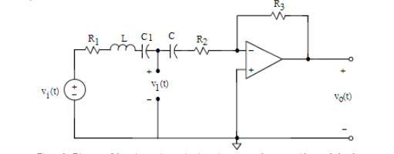

Figure 1. Diagram of the spirogravitator circuit

1. **Analysis and Design of Spirogravitator Circuit**

We had to derive two values from this circuit, V1 and V0. Doing this proved challenging, as we had to convert the whole circuit to the s domain. Converting the whole circuit to the s domain, and then assuming that C1 and C are equal we can simplify this circuit and take only the left half as picture in Figure 2. Summing up I(s) around the circuit we get Equation 1. We’ll have to convert this value back to the time domain by taking the inverse Laplace transform.

|  |  |  |
| --- | --- | --- |
|  |  | (1) |



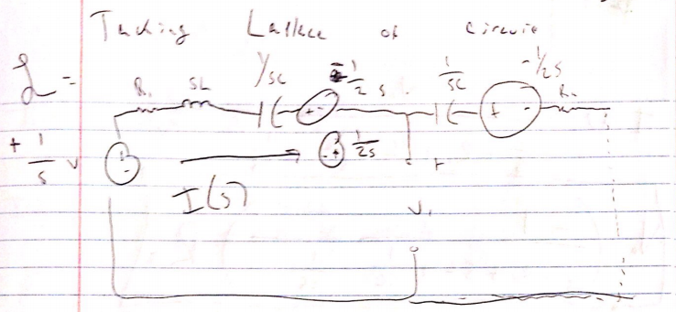

Figure 2. Laplace transform of circuit, excluding Op-Amp

Finding the equating for V0 is a little bit simpler. We can ignore the left-hand side of the circuit, but we still have to utilize a value for I(s). In figure 3, we can see that we get an equation for our V0 relationship.

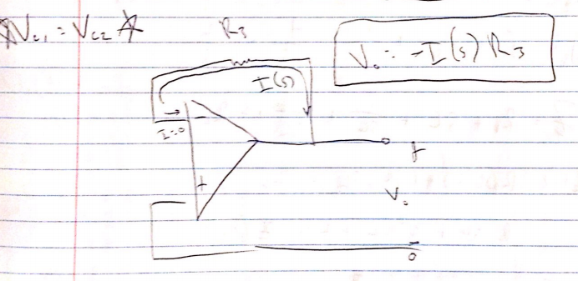

Figure 3. Op Amp side of Circuit

This gives us a convenient relationship for V0. Using this relationship, we can substitute back in for -I(s) and get an equation for V0 in the s domain.

|  |  |  |
| --- | --- | --- |
|  |  | (2) |

Now that we have both equations for V1 and V0 in the s domain, we just need to inverse Laplace them, back into the time domain. This will give us some helpful, complicated functions for V1 and V0. Deriving these expressions and putting them back into the time domain was difficult. The derived equations, 3 and 4, for alpha and beta are derived below.

|  |  |  |
| --- | --- | --- |
|  |  | (3) |
|  |  |  |
|  |  | (4) |

Taking equations 1 and 2 back into the time domain, will show all the circuit values we need. Knowing that the frequency needs to be somewhere around 5 kHz, we can set our equation of alpha equal to 5000. After preforming some calculations, we get that R1 = 750 Ω and R2 = 250 Ω. R3 value found was equal to approx. 4710 Ω. Using our equations given for beta, I was able to come up with equation 5.

|  |  |  |
| --- | --- | --- |
|  |  | (5) |

Solving equation 5, because we only need to find one value for C, C = 2.2 nF.

1. **Construction and Testing of Spirogravitator Circuit**

We took these two voltages and plotted them simultaneously on a dual-trace oscilloscope. Then, we were able to log the CSV files into Matlab and plot them vs. each other instead of respect to time. Figure 4 shows that V0 and V1 are 90º out of phase and their amplitudes are equal.

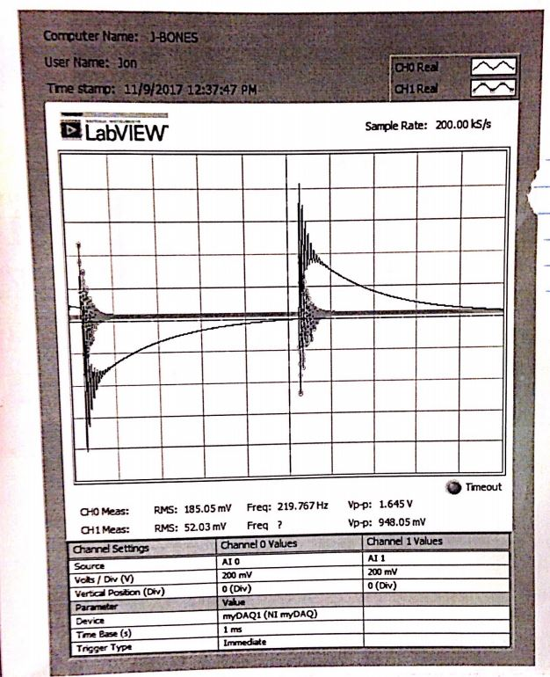

Figure . Double Spiral versus time

Using Matlab we were able to plot expected and actual measured double spirals, see Appendix A for Matlab code

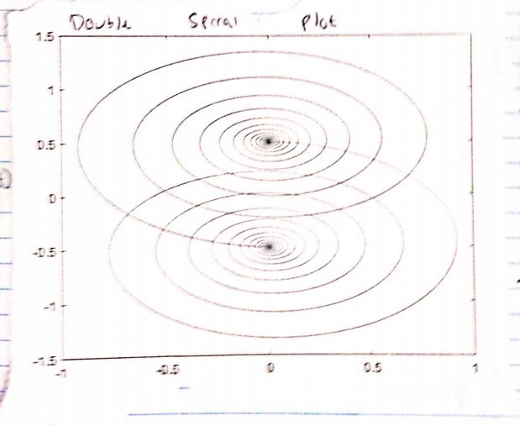

Figure . Expected Double Spiral Plot

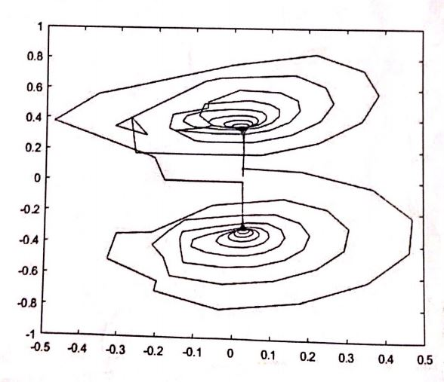

Figure . Actual Double Spiral Plot

**Conclusion**

Building the spirogravitator circuit, we were able to create two signals that were 90º out of phase. This circuit has many different uses that we could apply it to. Input V1(t) was a square wave that excites a damped oscillation in the series components to the left of the op-amp. V0 and V1 plotted as an x-y plot will showed a double spiral that was similar to the x-y plot we were expecting. In this report we talked about analysis and design of the circuit, construction and testing of the circuit and summarized our results and Matlab figures.

**Appendix A: Matlab Code**

%% Jonathan Pilling Lab 3 Double Spiral

% Here we will plug in V0 and V1 for the x and y values, and then plot

% these against each other

%Data points for the time domain

t = linspace(0, .01, 50000);

%This plot corresponds to V0(t)

x = -exp(-5000 * t) .* sin(30000 * pi * t);

%This function of y corresponds to the the V1(t)

y = 0.5 - exp(-5000 * t) .* cos(30000 * pi * t);

%Plots the first spiral

plot(x,y)

%This allows for multiple plots on the same figure

hold on

%This will plot the inverse of the first plot, with offset constant c

plot(-x,-y)